Evolution and Link Prediction of Protein Interaction Network in Yeast and Human

Yaoding Chen, Siqi Tian, Yifan Song, Patrick Wan Yon
- School of Biological Sciences, Nanyang Technological University, Singapore

Introduction
The protein-protein interaction network (PPIN) is among most studied biological networks, where biomolecules interact with each other to modulate essential biological functions such as muscle contraction, signal transduction, and membrane transport (Makino & Gojobori, 2007). However, although omics have enabled identification of a great number of proteins, over 30% of the identified proteins remain poorly understood functionally (Ellens et al., 2017). As protein-protein interactions (PPIs) are key to many biological functions, understanding how PPIs differ across species may provide valuable insights into gains and losses of biological functions indepdently of protein or genome sequences, which will be helpful to prediction of unknown protein interaction and unknown protein functions.
The molecular-clock hypothesis reveals that morphologically diverse species may undergo similar protein evolutionary rates (Kumar, 2005). Thus, by calculating conservation of the protein seqeuences in two species, one may estimate the time when the species diverged. While these conserved proteins preserve essential biological functions, lineage-specific proteins that come into being during evolution may further diversify biolgical functions de novo (Andersson et al., 2015). Thus, it is important to investigate whether and how the two kinds of proteins, i.e. conserved proteins and lineage-specific proteins, may differ or act similarly in PPI formation in the context of an expanding PPIN. Especially, we aim to describe the frequency of gains and losses of PPIs occuring to the two types of proteins.
In this paper, we will first have an overview of PPIN evolution by tapping into PPINs of different species with data from the Molecular INTeraction (MINT) database, which describes functionally associated PPIs in four major organisms. Second, we will use human and yeast PPIN to illustrate how gains and losses happen to proteins of different evolutionary history in the context of PPIN. Especially, we want to see whether certain network or node features in yeast PPIN may be related to transferability of PPIs to human PPIN. Third, we aim to construct a graph neural network (GNN) to test whether the features are sufficient to predict human PPIs among human homologs of the yeast proteins.

Related Work
参见：https://pubs.rsc.org/en/content/articlelanding/2010/mb/b916371a#cit113

Problem Statement and Hypothesis
Scale-free networks are networks of which the characteristics are independent of network, where the degree follow a power-law distribution, are assumed among the most common networks, of which formation can be well explained by growth and preferential attachment mechanisms (Piva et al., 2021).

Results

PPIN Evolution from Bacteria to Human
A growing body of peer-reviewed evolutionary biology literature estimating divergence times of different species has been synthesised in TimeTree database (Kumar et al., 2017), with which we created a species tree. The tree plot illustrates divergent times of our selection of organisms, i.e., human (Homo sapiens), mouse (Mus musculus), fruit fly (Drosophila melanogaster) and yeast (Saccharomyces cerevisiae), as is shown in Figure 1.
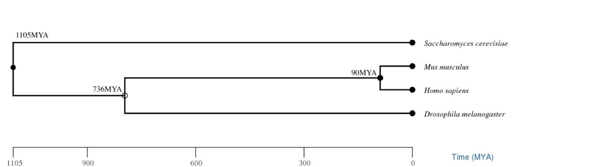

Figure 1. A species tree of the four species. Created with TimeTree (Kumar et al., 2017). MYA: million years ago; CI: 95% confidence level.

Figure 1 shows that the earliest divergence happened to yeast and fruit fly 1105 million years ago (MYA), followed by the divergence between two mammals and fruit fly 736 million years ago. The latest divergence happened to human and mouse 90 million years ago.

To study evolutionary changes of PPIs, we used PPI data from four different animals provided by the MINT database to construct our PPINs (Licata et al., 2012). Figure 2 shows the number of nodes and edges, two indicator of network size, in the four PPINs, which suggests distinct sizes of PPINs of the four species. It is clear that human and yeast PPIN are among the most studied PPINs, as they have the largest number of known PPIs. Human and mouse have larger number of nodes, yet the number of edges of mouse PPINs may still underestimated considering relative higher number of edges in yeast and human PPINs.

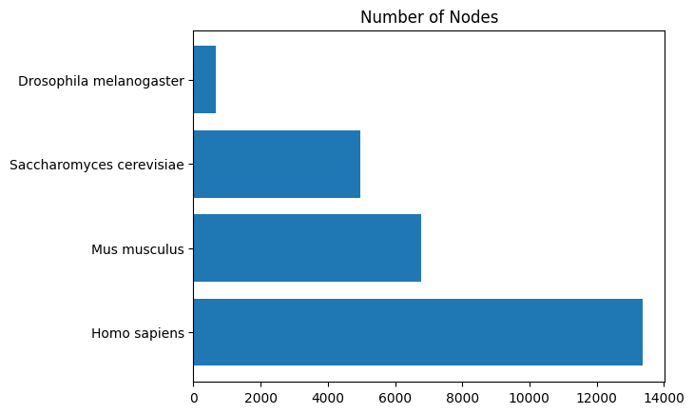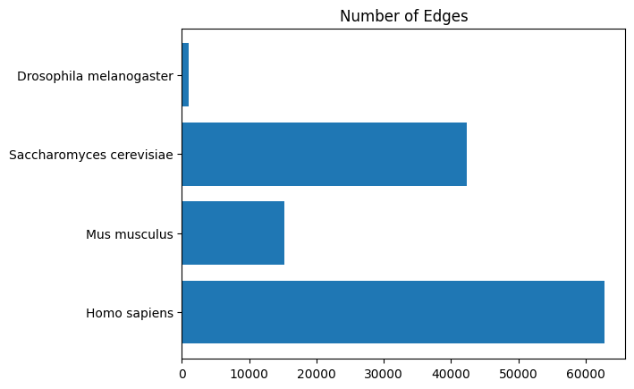

Species | Number of nodes | Number of edges
Homo sapiens | 13367 | 62772
Mus musculus | 6780 | 15160
Saccharomyces cerevisiae | 4972 | 42351
Drosophila melanogaster | 664 | 98

Figure 2. Total node number (left) and total edge number (right) of four PPINs.

Though often claimed in complex networks including PPINs, the universality of such networks is being criticised (Broido & Clauset, 2019), for which a possible reason is subnetting of a scale-free network (Stumpf et al., 2005). Thus, we should first examine the degree distribution of the networks presented by the database, as being scale-free is essential to network dynamics such as preferential attachment and growth, which may help us to explain how a PPI is formed de novo and how the PPIN evolves.

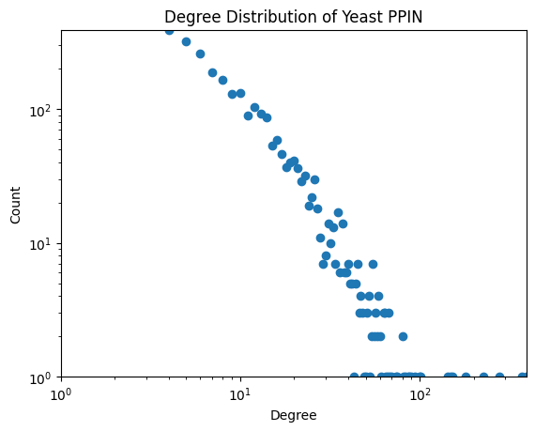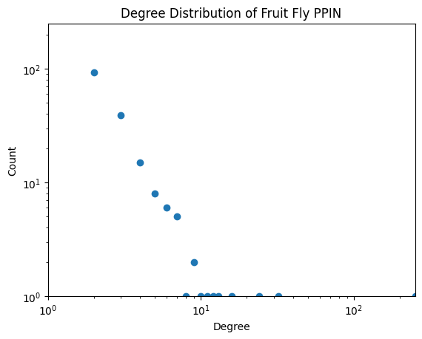
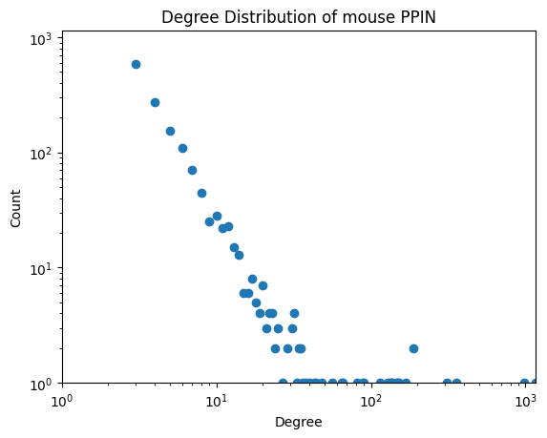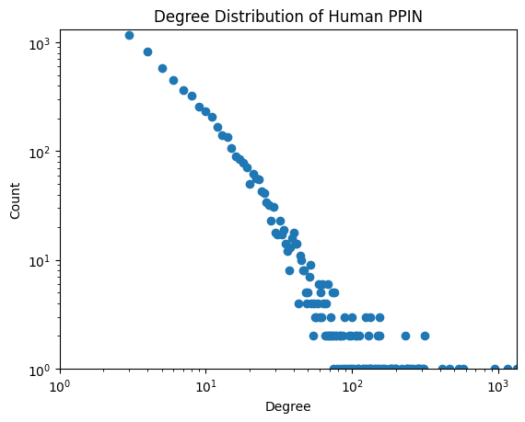
Figure 3. Degree distribution of four PPINs.

Figure 3 shows the degree distribution of the four PPINs, which all follows a power-law distribution, supporting a scale-free nature of PPINs during evolution. This means network properties are independent of network sizes. Also, the above figures also show that human and yeast PPINs contains more known network details than other PPIN due to more research on them. Thus, these features make us interested in them
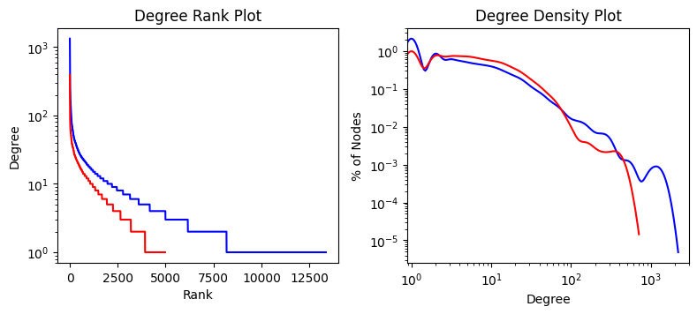
Figure 4. Degree rank plot and degree histogram of human and yeast PPINs.

Figure 4 shows the degree rank plot and the degree histogram of human and yeast PPINs combined, which exhibits a highly skewed degree distribution in both PPINs. This is expected in a scale-free network or similar real-world networks, where only a few nodes are connected to a large number of nodes, while most of the other nodes are only weakly connected to the network. Thus, it may be expected that during evolution, de novo protein will be first be attracted to these proteins highly connected to other proteins.

Evolution-based Protein Categorisation in PPIN
Here, we first use simple match method to examine the node list of yeast PPIN, with no regard of sequence change rates. To achieve this, we used Ensembl Rest API and g:Profiler to retrieve all protein homologs of the yeast PPIN nodes (Howe et al., 2021; Raudvere et al., 2019; Yates et al., 2015). If the API returns no protein homolog in human, we consider the yeast protein to be yeast-specific or else the yeast protein is conserved. Thus, we can have two categories of yeast proteins. Among 4972 yeast PPIN nodes, 1787 are conserved while the remaining 3185 are yeast-specific. Then the conserved yeast proteins are mapped to 3295 human proteins which we considered to be conserved human proteins, yet only 2216 are mapped to human PPIN nodes, leaving the remaining 11151 to be human-specific. The categorisation results are illustrated in Figure 5 below.

Then we are interested in how biological functions may be retained by the conserved proteins. Therefore, we perform gene set enrichment analysis (GSEA) based on Gene Ontology (GO), which is a controlled vocabulary to describe biological functions. Thus, we use GO terms as a proxy of biological functions. The functional similarity between proteins can therefore be measure with semantic similarity of GO terms associated with the two proteins (Supplement Data).

Each GO term is associated with a set of pre-determined gene name list (Vesztrocy & Dessimoz, 2017). As our networks do not have a complete gene list of either human or yeast, we use the node list of the two network as a background when performing GSEA (Simillion et al., 2017).

Figure 6 shows the result of our analysis, where the enriched terms are considered proxies of biological functions so that we can look into cross-species transfer of biological function via protein conservation.

代码参见：https://github.com/nguyenquyem99dt/Evolution-and-Link-Prediction-of-Wikipedia/blob/main/evolution_of_wiki.ipynb

Homology-based Protein Categorisation

Wan Yon

ID conversion (Howe et al., 2021; Yates et al., 2015)
Protein Gene Conservation using BioMart (Howe et al., 2021)

图片1：各种类型protein的数量（已经有了）

图片2：各种类型protein的GSEA结果的（已经有了）

图片3：GSEA结果的GO term/Kegg pathway overlap的Venn图
- human_conserved vs yeast conserved;
- human specific vs yeast specific;
- human specific vs human conserved;
- yeast specific vs yeast conserved

图片4：各种类型protein的GSEA结果的WordCloud（记得在frequency list里面删去无意义的词语）

图片5：用enriched term标注gene ontology有向无环图（就是那天看到的那种树状图一样的东西）

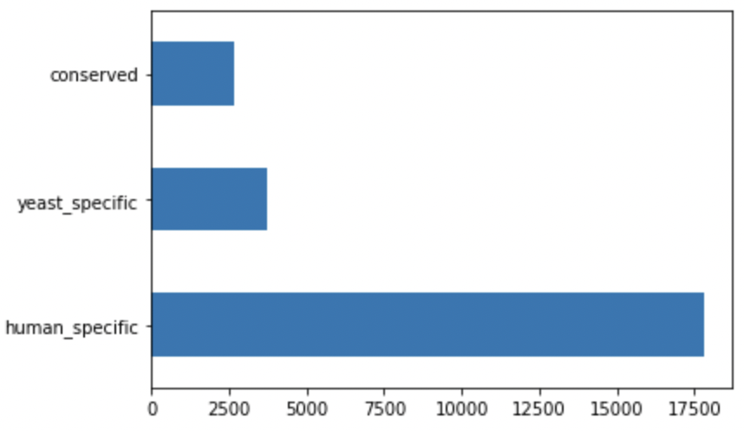
Gene set enrichment results of different evolutionary type (which suggests difference in functionality conservation)

Network Properties of Conserved and Lineage-specific Proteins

Siqi
图片1：Sequence Change Rate of Conserved protein （数据已经下载.protein_evo_details，用identical to yeast protein的数据）
图片2：Centrality vs Sequence Change Rate vs Neighbour Change Rate (Pairplot)
图片3：Centrality vs Sequence Change Rate vs Conserved Neighbour Change Rate (Pairplot) vs Lineage-specific Neighbour Change Rate

参见：
The Role of Lineage-Specific Gene Family Expansion in the Evolution of Eukaryotes https://www.ncbi.nlm.nih.gov/pmc/articles/PMC186617/
Conserved patterns of protein interaction in multiple species https://www.pnas.org/content/102/6/1974
Evolution of New Functions De Novo and from Preexisting Genes https://www.ncbi.nlm.nih.gov/pmc/articles/PMC4448608/
Biological function in the twilight zone of sequence conservation https://bmcbiol.biomedcentral.com/articles/10.1186/s12915-017-0411-5

Predicting Human PPI with Yeast PPI Data
Siqi
模型：Graph Neural Network 参见：
http://snap.stanford.edu/deepnetbio-ismb/ipynb/Graph+Convolutional+Prediction+of+Protein+Interactions+in+Yeast.html
代码参见：https://github.com/nguyenquyem99dt/Evolution-and-Link-Prediction-of-Wikipedia/blob/main/link_prediction_of_wiki.ipynb

原本参数选择：common_neighbors / jaccard_coefficient / preferential_attachment
可参考参数选择：common_neighbors / conserved_neighbour / centrality ??? (不确定 preferential_attachment是否有用)

Discussion

Missing PPIs
https://journals.plos.org/plosone/article?id=10.1371/journal.pone.0177029

Conclusion

- Data Availablbity
The data collection processes have been detailed in the main text. All the code is available at https://github.com/ydchen17/PPI_Analysis_Project

References
Andersson, D. I., Jerlström-Hultqvist, J., & Näsvall, J. (2015). Evolution of new functions de novo and from preexisting genes. Cold Spring Harbor Perspectives in Biology, 7(6), a017996. https://doi.org/10.1101/cshperspect.a017996
Broido, A. D., & Clauset, A. (2019). Scale-free networks are rare. Nature Communications, 10(1), 1017. https://doi.org/10.1038/s41467-019-08746-5
Ellens, K. W., Christian, N., Singh, C., Satagopam, V. P., May, P., & Linster, C. L. (2017). Confronting the catalytic dark matter encoded by sequenced genomes. Nucleic Acids Research, 45(20), 11495–11514. https://doi.org/10.1093/nar/gkx937
Howe, K. L., Achuthan, P., Allen, J., Allen, J., Alvarez-Jarreta, J., Amode, M. R., Armean, I. M., Azov, A. G., Bennett, R., Bhai, J., Billis, K., Boddu, S., Charkhchi, M., Cummins, C., Da Rin Fioretto, L., Davidson, C., Dodiya, K., El Houdaigui, B., Fatima, R., … Flicek, P. (2021). Ensembl 2021. Nucleic Acids Research, 49(D1), D884–D891. https://doi.org/10.1093/nar/gkaa942
Jin, Y., Turaev, D., Weinmaier, T., Rattei, T., & Makse, H. A. (2013). The Evolutionary Dynamics of Protein-Protein Interaction Networks Inferred from the Reconstruction of Ancient Networks. PLOS ONE, 8(3), e58134.
Kumar, S. (2005). Molecular clocks: four decades of evolution. Nature Reviews Genetics, 6(8), 654–662. https://doi.org/10.1038/nrg1659
Kumar, S., Stecher, G., Suleski, M., & Hedges, S. B. (2017). TimeTree: A Resource for Timelines, Timetrees, and Divergence Times. Molecular Biology and Evolution, 34(7), 1812–1819. https://doi.org/10.1093/molbev/msx116
Licata, L., Briganti, L., Peluso, D., Perfetto, L., Iannuccelli, M., Galeota, E., Sacco, F., Palma, A., Nardozza, A. P., Santonico, E., Castagnoli, L., & Cesareni, G. (2012). MINT, the molecular interaction database: 2012 update. Nucleic Acids Research, 40(D1), D857–D861. https://doi.org/10.1093/nar/gkr930
Makino, T., & Gojobori, T. (2007). Evolution of protein-protein interaction network. In Genome Dynamics (Vol. 3, pp. 13–29). Karger Publishers. https://doi.org/10.1159/000107601
Piva, G. G., Ribeiro, F. L., & Mata, A. S. (2021). Networks with growth and preferential attachment: modelling and applications. Journal of Complex Networks, 9(1). https://doi.org/10.1093/comnet/cnab008
Raudvere, U., Kolberg, L., Kuzmin, I., Arak, T., Adler, P., Peterson, H., & Vilo, J. (2019). g: Profiler: a web server for functional enrichment analysis and conversions of gene lists (2019 update). Nucleic Acids Research, 47(W1), W191–W198.
Simillion, C., Liechti, R., Lischer, H. E. L., Ioannidis, V., & Bruggmann, R. (2017). Avoiding the pitfalls of gene set enrichment analysis with SetRank. BMC Bioinformatics, 18(1), 151. https://doi.org/10.1186/s12859-017-1571-6
Stumpf, M. P. H., Wiuf, C., & May, R. M. (2005). Subnets of scale-free networks are not scale-free: sampling properties of networks. Proceedings of the National Academy of Sciences of the United States of America, 102(12), 4221–4224. https://doi.org/10.1073/pnas.0501179102
Vesztrocy, A. W., & Dessimoz, C. (2017). A Gene Ontology Tutorial in Python BT - The Gene Ontology Handbook (C. Dessimoz & N. Škunca (eds.); pp. 221–229). Springer New York. https://doi.org/10.1007/978-1-4939-3743-1_16
Yates, A., Beal, K., Keenan, S., McLaren, W., Pignatelli, M., Ritchie, G. R. S., Ruffier, M., Taylor, K., Vullo, A., & Flicek, P. (2015). The Ensembl REST API: Ensembl Data for Any Language. Bioinformatics, 31(1), 143–145. https://doi.org/10.1093/bioinformatics/btu613

- Supplementary Figures

Human specific
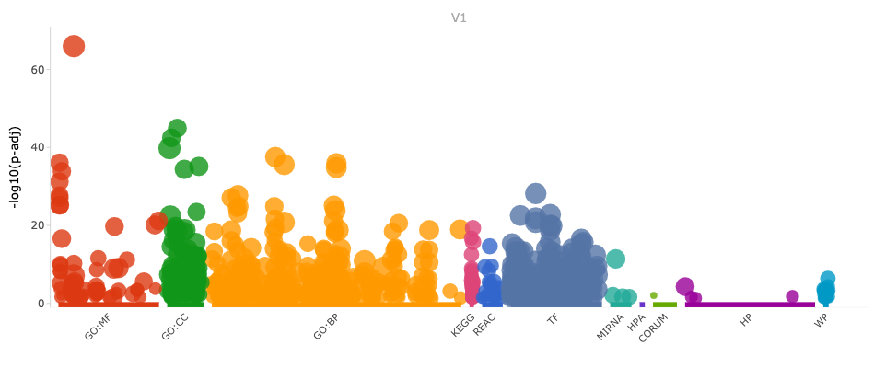Human conserved
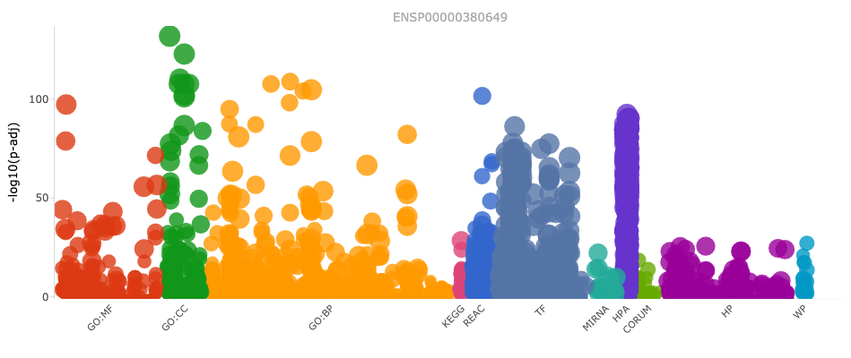

Yeast specific
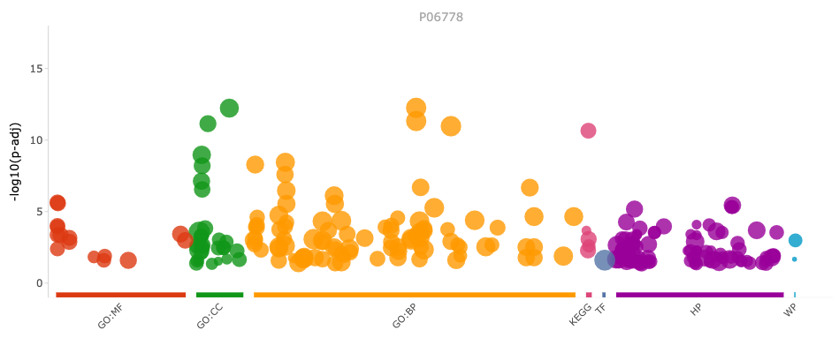
Yeast conserved
